## SQL Homework 4 – Summarizing Data

**Section 1**

Create SQL commands to answer the following questions using the tables in the classicmodels database shown below. To maintain a record of your homework, use this document to record your SQL code and results from the results grid.

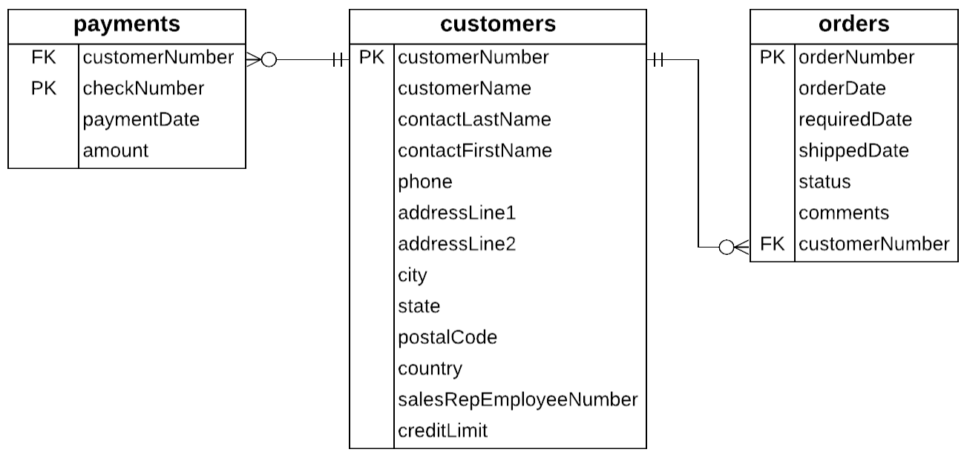

1. **Show the customer number and count of checks by customer number in the payments table. Use the alias N_Payments for the counts.**

SELECT customerNumber,

COUNT(checkNumber) as 'N_Payments'

FROM payments

GROUP BY customerNumber

1. **Show the count of checks by year of payment date in the payments table. Use the alias N_Payments for the counts and the alias YearofPayment for the year. HINT: Use the same code as problem 1 but replace customerNumber with Year(paymentDate).**

SELECT year(paymentDate) AS 'YearofPayment',

COUNT(checkNumber) as 'N_Payments'

FROM payments

GROUP BY Year(paymentDate)

1. **Show the customer number and the total payments made by customer (use SUM()). Use the alias Total_Paid. Order by the total paid from largest to smallest.**

SELECT customerNumber,

SUM(amount) AS ‘Total_Paid’,

FROM payments

GROUP BY customerNumber

ORDER BY Total_Paid DESC

1. **Show the minimum, maximum, and average credit limit by city. Use the aliases Min_Limit, Max_Limit, and Average_Limit. Use the ROUND() function so 0 decimal places are displayed for the numeric fields. Order by city in alphabetical order.**

SELECT city,

ROUND(MIN(creditLimit)) AS Min_Limit,

ROUND(MAX(creditLimit)) AS Max_Limit,

ROUND(AVG(creditLimit)) AS Average_Limit,

FROM customers

GROUP BY city

ORDER BY city

1. **Show the minimum, maximum, and average credit limit by city and country. Use the aliases Min_Limit, Max_Limit, and Average_Limit. Use the ROUND() function so 0 decimal places are displayed for the numeric fields. Sort by country then city in alphabetical order.**

SELECT country, city,

ROUND(MIN(creditLimit)) AS Min_Limit,

ROUND(MAX(creditLimit)) AS Max_Limit,

ROUND(AVG(creditLimit)) AS Average_Limit,

GROUP BY country, city

ORDER BY country, city

1. **Show the number of customers and average credit limit for customers in the United States (USA). Use appropriate aliases and round the average credit limit to 0 decimal places. (HINT: use a WHERE clause to select the country.)**

SELECT

COUNT(*) AS numberCustomers,

ROUND(AVG(creditLimit),0) AS Average_Limit

FROM customers

WHERE country='USA'

1. **Show the year, month and total payments received each month during the year 2005 (use SUM()). Use an alias for the total payments and month of payment.**

SELECT Year(PaymentDate), MONTH(PaymentDate) AS Payment_Month,

SUM(amount) AS Total_Payments

FROM payments

WHERE Year(paymentDate)=2005

GROUP BY Payment_Month;

**Section 2**

Use this ERD to write the queries in problems 8 and 9.

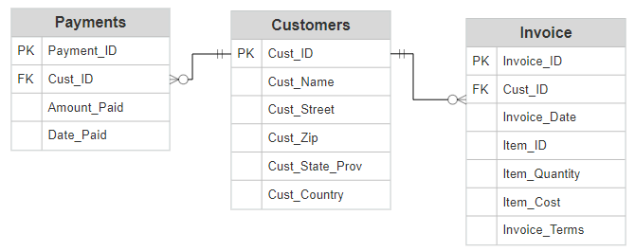

1. **Write a query that shows the country and count of customers by country. Use an alias for the count.**

SELECT Cust_Country,

COUNT(Cust_ID) AS ‘CustomersPerCountry’

FROM customers

GROUP BY Cust_Country

ORDER BY Cust_Country

1. **Write a query that shows the month and the sum of payments received each month in the year 2019. Use an alias for month and sum of payments. Use the WHERE clause to select payments from 2019.**

SELECT Month(Date_Paid) AS PaymentMonth,

SUM(Amount_Paid) AS MonthlyAmount

FROM Payments

WHERE Year(Date_Paid)=2019

GROUP BY Month(Date_Paid)

ORDER BY Month(Date_Paid)

**Section 3**

All of the queries in this section require a GROUP BY and HAVING clause.

1. **Use the classicmodels database to answer this question. Write a query to show the customer number and sum of payments for customers who have made payments totaling more than $150,000. Use an alias for calculated fields.**

SELECT customerNumber,

SUM(amount) AS TotalPaid

FROM payments

GROUP BY customerNumber

HAVING SUM(amount) >= 150000

1. **Use the classicmodels database to answer this question. Write a query to show the country name and count of customers for all countries with more than 5 customers. Use an alias for calculated fields.**

SELECT country,

COUNT(*) AS TotalCustomers

FROM customers

GROUP BY country

HAVING COUNT(*) >5

Use this ERD to answer the following two questions.

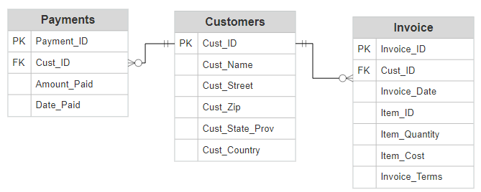

1. **Write a query to show the customer ID and count of payments for customers who have made more than 10 payments. Use an alias for calculated fields.**

SELECT Cust_ID,

COUNT(*) AS NumberOfPayments

FROM payments

GROUP BY Cust_ID

HAVING NumberofPayments > 10

1. **Write a query to show the item ID and average item cost for items with an average cost greater than $20. Item cost is a numeric field. Use an alias for calculated fields.**

SELECT Item_ID,

AVG(Item_Cost) AS AveragePrice

FROM Invoice

GROUP BY Item_ID

HAVING AveragePrice >20